Synthetic Classification Project
Machine Learning Pipeline
Prepared by Ahmed Abdullatef
Date: December 5, 2025

Introduction
In this project we develop a complete machine-learning pipeline on a synthetic classification dataset containing 12 000 samples and eight features. The objective is to predict a binary target variable using two machine-learning algorithms—logistic regression and random forest—and to compare their performance. The dataset was generated using scikit-learns make classification function, which produces Gaussian clusters of points with controlled informative and redundant features. This synthetic setting allows us to illustrate core steps such as data exploration, preprocessing, model training, evaluation and interpretation without depending on external data downloads.
Data: The synthetic dataset consists of 12000 observations with 8 input features and one binary target label. Five features are informative and two are redundant combinations of the informative ones. The remaining feature contains random noise. The class distribution is moderately imbalanced with approximately 60 % of samples in class 0 and 40 % in class 1. Prior to modeling we explore the data through visualizations and compute descriptive statistics.
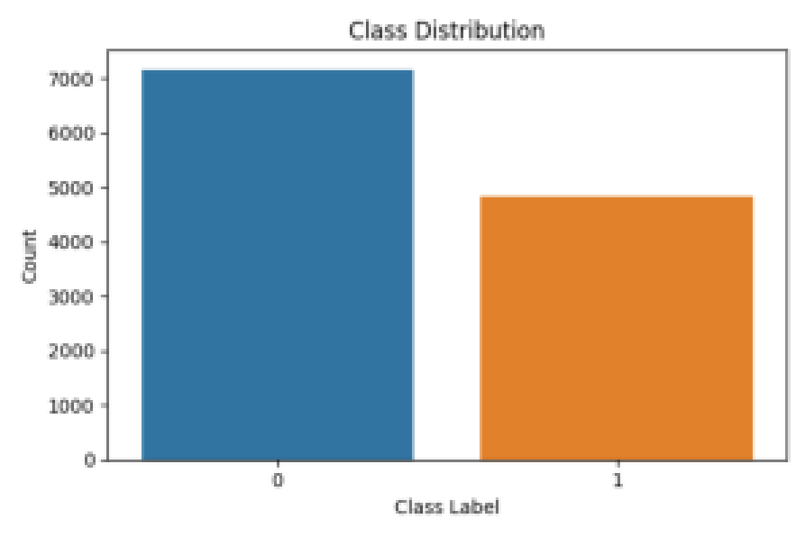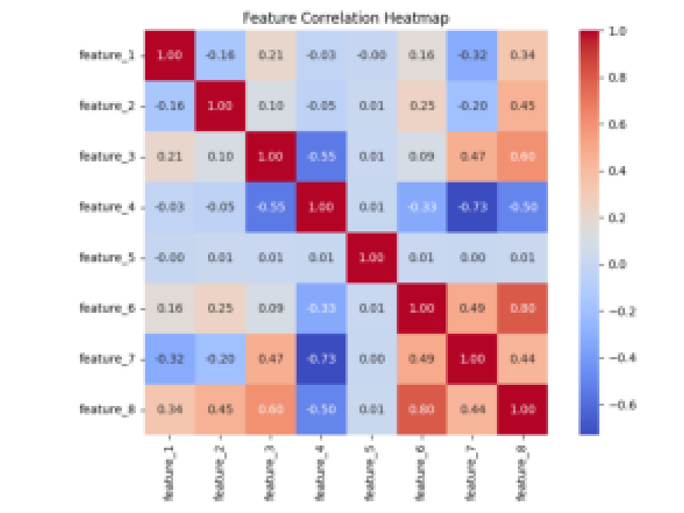

Preprocessing: Because all features are continuous, we standardize them to zero mean and unit variance using scikitlearn’s StandardScaler. This transformation ensures that the logistic regression model converges properly and that the random forest is not unduly influenced by differing scales across features. There are no missing values in this synthetic dataset, so imputation is unnecessary.

Methods:
We train two supervised learning algorithms: (1) Logistic Regression and (2) Random Forest. Logistic regression is a simple yet powerful baseline model that estimates the probability of the positive class using the logit function. It assumes a linear relationship between the log-odds of the target and the features. Random forest is an ensemble method that constructs many decision trees on bootstrap samples and aggregates their predictions to improve accuracy and reduce overfitting. Each tree in the forest is trained on a random subset of features, which decorrelates the individual trees and leads to better generalization. We use 5-fold cross-validation to assess the stability of the logistic regression model and evaluate both models on a held-out 20 % test set.
Results

The logistic regression model achieved an accuracy of 0.85, precision of 0.81, recall of 0.82, and F1 score of 0.81 on the test set. Fivefold crossvalidation across the entire dataset yielded a mean accuracy of 0.85 ±score of
0.01. The random forest model performed better with an accuracy of 0.97, precision of 0.96, recall of 0.96, and F1score of 0.96. The area under the ROC curve (AUC) was 0.91 for logistic regression and 0.98 for random forest, indicating superior discriminative ability for the random forest.
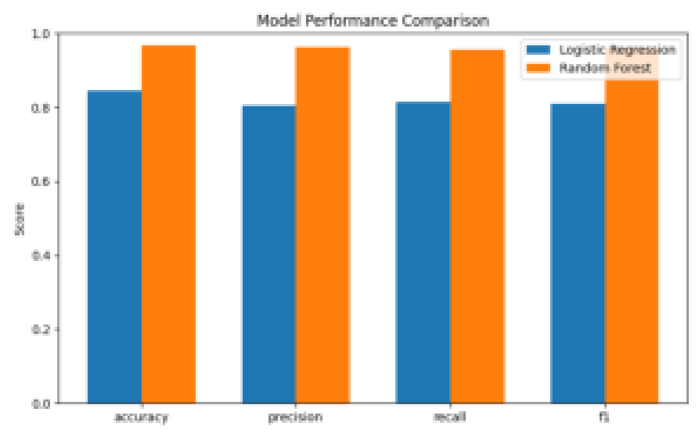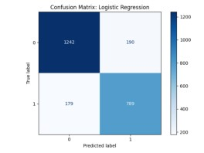
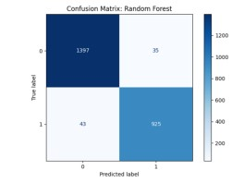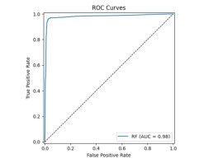

Discussion: The superior performance of the random forest can be attributed to the ability of the ensemble to capture nonlinear relationships and feature interactions that the linear model cannot. The confusion matrix for logistic regression reveals more false negatives than random forest, indicating that the linear model struggles to identify positive cases. The ROC curves show that random forest yields a higher true-positive rate across most thresholds. Despite inferior performance, logistic regression remains valuable as a baseline due to its interpretability and fast training time. Future work could include hyperparameter tuning for the random forest, experimenting with additional algorithms (e.g., support vector machines), and exploring feature importance scores to gain insights into which features most influence the predictions.

Conclusion: This project demonstrates the end-to-end process of building and evaluating machine-learning models on a medium-sized dataset. Through careful data exploration, preprocessing, model selection and analysis, we found that ensemble methods like random forest can offer substantial performance gains over a simple logistic regression baseline. The exercise also underscores the importance of cross-validation and proper evaluation metrics when comparing models. Finally, generating a synthetic dataset with scikit-learn’s tools provided a controlled environment to test our knowledge without relying on external data.

References
- Datacamp. "Understanding Logistic Regression in Python." DataCamp, updated 11 Aug. 2024,https://www.datacamp.com/tutorial/understanding-logistic-regression-python. Accessed 6 Dec. 2025.
- Datacamp. "Random Forest Classification in Python with ScikitLearn: Step by Step Guide." DataCamp, updated 31 Oct. 2025, https://www.datacamp.com/tutorial/random-forests-classifier-python. Accessed 6 Dec. 2025.
- scikitlearn developers. "sklearn.datasets.make_classification." scikit learn 1.7.2 Documentation, https://scikit-learn.org/stable/modules/generated/sklearn.datasets.make_classification.html. Accessed 6 Dec. 2025.
- Wikipedia contributors. "Random forest." Wikipedia, The Free Encyclopedia, https://en.wikipedia.org/wiki/Random_forest. Accessed 6 Dec. 2025.

Acknowledgement
This project was conducted independently using open-source Python libraries (pandas, NumPy, scikit-learn, seaborn and Matplotlib). All analyses and code were written by me; no pre-written solutions or unauthorized assistance were used. I did consult ChatGPT for general guidance on structuring the report and clarifying conceptual questions, but all implementation and analysis decisions reflect my own work and understanding.
Source code:

The complete source code for generating the synthetic dataset, performing the exploratory analysis, training the models, and assembling this report is contained in my Python script (project_analysis.py). I wrote this code myself; ChatGPT did not generate any code, but provided conceptual guidance as noted in the Acknowledgement. To make the code accessible for grading, create a public repository (for example on GitHub), upload project_analysis.py, and include the repository link in this section. This allows reviewers to view and run the script to reproduce the results.

